EXPERIMENT 5

5.Create a simple cloud software application for product selling using any cloud service provider to demonstrate saas.

Aim
To develop a simple cloud-based Product Selling System using Zoho Creator as a Cloud Service Provider and to demonstrate the Software as a Service (SaaS) model for managing product sales and customer orders.

Procedure
- Log in to Zoho Creator.
- Create a new application in Zoho Creator named Product Selling System.
- Create a single form named Product Selling Details and add customer, product, payment, and delivery fields.
- Configure the required field types such as Name, Phone, Email, Number, Currency, Date, and Drop Down.
- Add a simple workflow to calculate the total amount based on the product quantity and price per unit.
- Enter sample product order details, submit the form, and verify the stored records in the cloud application.

Implementation
The Product Selling System was implemented using Zoho Creator as the cloud service provider. A single form named Product Selling Details was created with fields such as customer name, phone number, email, product ID, product name, category, quantity, price per unit, total amount, payment method, order date, delivery address, delivery status, and payment status. A workflow was added to calculate the total amount automatically. Sample product orders were entered and tested, and the records were successfully stored and managed through the cloud application.

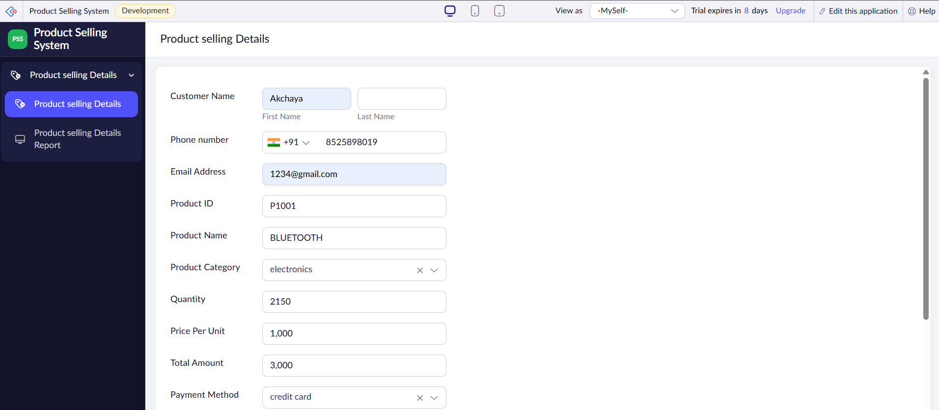

FIGURE 1:PRODUCT SELLING SYSTEM FORM

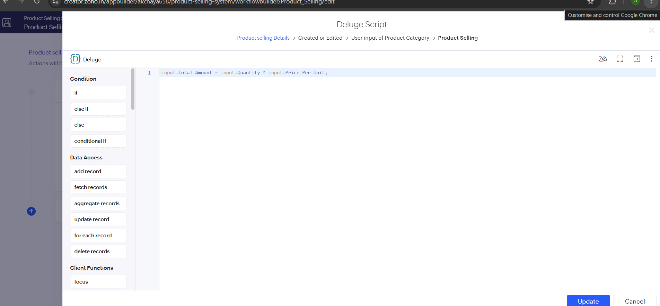
FIGURE 2: WORKFLOW

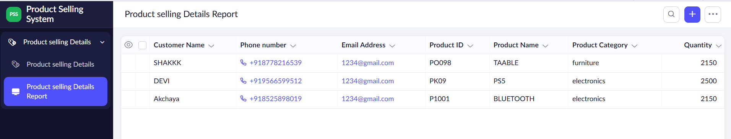
FIGURE 3: PRODUCT SELLING SYSTEM REPORT

Result
Thus, the Product Selling System was successfully developed using Zoho Creator. The application enables users to manage customer details, product information, order quantity, payment details, and delivery status efficiently. The experiment successfully demonstrated the Software as a Service (SaaS) model through a cloud-based application for product selling.

